**Design Document**

**Media storage service**

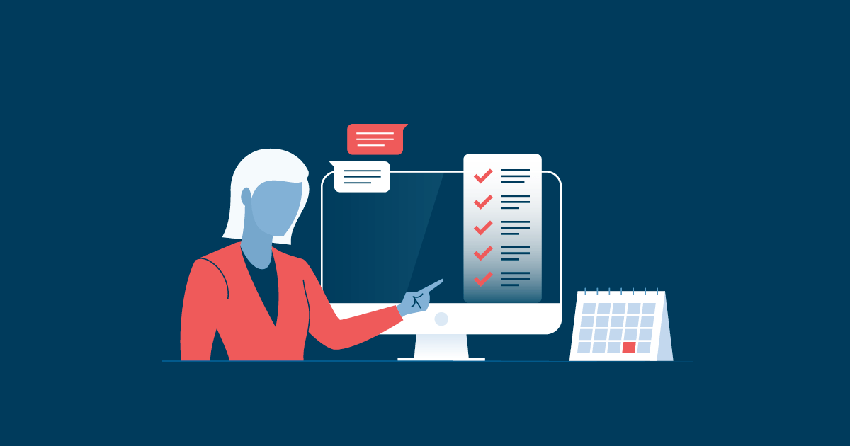

Project Members:

* Kaloyan Andreev

Elaboration Date: 20/05/2022

Table of content

1. Detailed design 2

2. Work estimates 5

3. Roll-out plan 6

4. Related work 7

5. Future work 8

6. C4 Model diagram 9

6.1. System context 9

6.2. Container diagram 9

7. UML diagram 10

8. ERD diagram 11

9. Use Case Diagram 12

# Detailed design

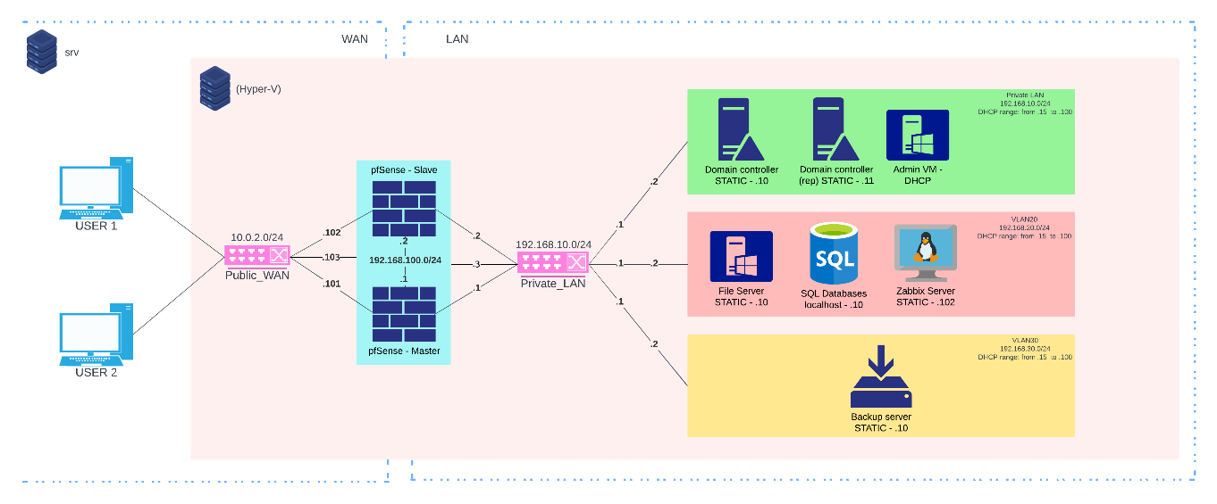The project is hosted on on-premises server the infrastructure will be created. It will contain a Firewall, an Active Directory, a Client Server and an admin user machine. For the firewall, it was chosen PfSense software while for the other machines - Windows Server 2019. The Client Server is the one hosting the web-based access application for clients and there will also be stored all the client data.

Microsoft SQL Server database will hold important data both for the clients and for the company’s employees. A table for the company employees contains user login credentials and personal data such as ID number, Name, DOB, Phone number, email, address. Similar information holds the clients’ table. It has client login credentials plus ID, name, DOB, email, phone number and storage directory path.

For this project, a new application is developed specially designed for our needs. It contains a simple login page and a simplified interface of the users directory with all of the files they have access to. It will provide a secure access to the server.

The whole process takes no more than a usual upload and is dependent on the client’s internet speed. Space-wise our product is as efficient as it gets by utilizing dynamic memory and different access levels. It is expected the Client Server to be the most accessed part of the infrastructure with the highest load.

During the use of our product errors could happen. Apart from the more obvious network error messages, the first and most basic one is wrong credentials. Corrupted file is another error state. Other error states include:

* **File does not exist**
* **File could not be uploaded**
* **File already exists**
* **Synchronisation error**
* **Server down for maintenance**
* **Unknown error we are working on a fix**

To keep the servers healthy, there is a sophisticated logging and monitoring policy. With the help of Zabbix all logs, and state of the machines is monitored through the admin user machine. It has full control over the servers and keeps a detailed log on events that are happening on it. By taking these extra measures, it is expected to limit the amount of server errors to a minimum and improve the user experience.

For the same reason, regular security checks will be performed and there will be a detailed security analysis of the system. To avoid different threats different measures are being taken. The most basic one is a regular backup which includes a copy off-site thus making sure there is always a state to revert to.

As this is a multi-user platform there are some privacy concerns for which the privacy policy will be constantly up to date. The system will be regularly tested and make sure each client has the promised privacy. Their data is not only private from outside factors but also from other users and employees.

# Roll-out plan

The application will be online by week 4 and will be accessible to the public by week 6. In the meantime, tests need to be performed on the security and the infrastructure product. After week 5 and week 6 the new updated of the application will be uploaded and implemented following more tests to ensure the changes have fixed the issues and to find other potential problems.

# Related work

There is another project online similar to this on which are worth looking into:

* Logo

  Description automatically generated with medium confidenceGoogle Drive
* Dropbox
* MEGA
* Logo, company name

  Description automatically generatedOneDrive
* 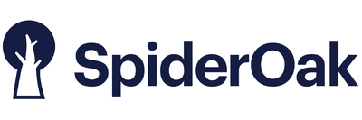SpiderOak One

# Future work

The plans include creating a cross-platform application. Goal is to make this application accessible for multiple devices and to make it possible to upload files from anywhere securely if there is internet. There is a plan to have backup server for when the amount of user grows and lastly – implementation of RAID storage system that will prevent from data loss.

# C4 Model diagram

## System context

## Container diagram

# UML diagram

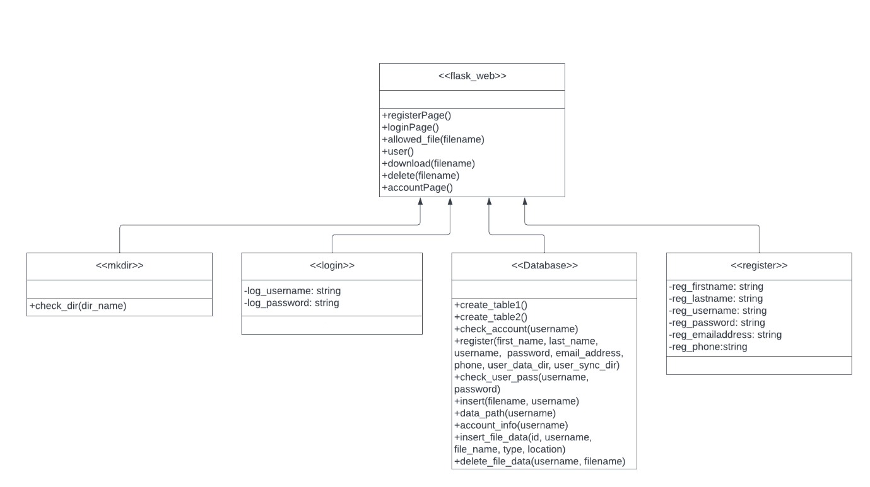

# ERD diagram

# Use Case Diagram

